1.INTRODUCTION

1.1 Overview

This report delves into the captivating realm of India's agricultural cultivation, providing a comprehensive visual exploration of key aspects and trends in the agricultural sector. Through the visual representations, readers can gain valuable insights into crop production, seasonal variations, regional distribution, and overall production trends. These visualizations enable intuitive analysis, allowing stakeholders to uncover patterns, identify areas of growth or concern, and make data-driven decisions.

1.2 Purpose

The primary business requirements for this report are to visualize and analysis business expenses, provide industry-specific insights, identify cost drivers, highlight outliers, and offer interactive functionality. Stakeholders need a visual representation of expenses to compare and analysis spending patterns across different businesses and industries. The report should facilitate the identification of key cost drivers, enabling stakeholders to understand the primary factors contributing to expenses. Additionally, it should flag any outliers or anomalies for further investigation. The report should provide a user-friendly and intuitive experience that empowers stakeholders to make data-driven decisions and drive positive change in the agricultural sector.

**2. Problem Definition& Design Thinking**

2.1 Empathy Map



**2.2 Ideation & Brainstorming Map**



**3 RESULT**

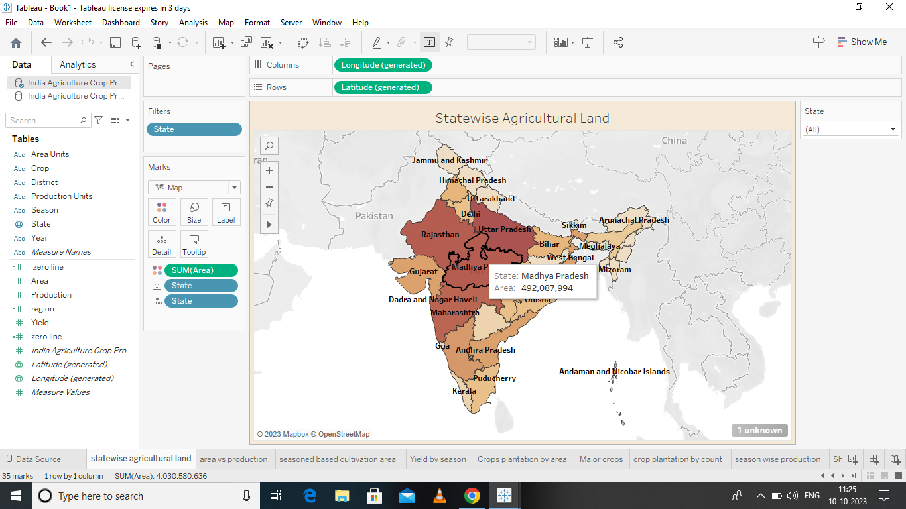

**4 ADVANTAGES& DISADVANTAGES**

**ADVANTAGES:**

Organic farming usually goes down in a natural environment.

Unnecessary enclosures are not used for the crops or plants.

This way the productivity is increased and is way better compared to closed spaces

**DISADVANTAGES**

If you’re looking to know how to start organic farming , these pointers should be kept in mind. Now that we’ve seen the positive side to organic farming , let us move on to the negative .The following are disadvantages of organic farming.

**5.APPLICAIONS**

Agricultural applications means applications relating to (1)cultivating , characterizing or modifying soil ;(2)producing , growing , improving , treating or modifying crops or forest products ;(3) raising , harvesting , improving , protecting , treating or modifying livestock , poultry .

**6. CNCLUSION**

The Indian economy is an agricultural-economy and depends highly on the agricultural sector.

**7.FUTURE SCOPE**

There is a tremendous scops for agricultural because food & food products are indispensable for the survival of humanity.

**8.APPENDIX**

A. source Code